**British Columbia Physical Education Curriculum: Dance, Gymnastics, Yoga**

*“The aim of the Physical Education is to enable all students to develop knowledge, movement skills and positive attitudes and behaviours that contribute to a healthy, active lifestyle.”*

**K-7 BC IRP**

**Curriculum Organizers:**

* Body and Space awareness
* Non-locomotor movement skills
* Locomotor movement skills

**Activity Categories**

A balanced physical education program includes opportunities for students to participate in a variety of activities across 5 categories including:

1. Dance
2. Gymnastics
3. Individual Activities (Yoga)

**Gr. 8-12 BC IRP**

**Curriculum Organizer:**

Movement Skills applied in:

* individual activities
* rhythmic movement (including dance and gymnastics)
* application of movement concepts and principles of training

**Activity Categories:**

1. Individual Activities: Yoga
2. Rhythmic Movement: Dance and Gymnastics

**About Kerry Turner**

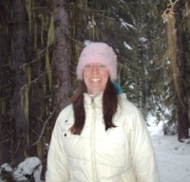

Kerry Turner is a Certified Teacher currently teaching as a teacher-on-call in the school district #20. Kerry graduated in August 2009 with a Bachelor of Education degree from the UBC WKTEP program specializing in Physical Education and Science. Kerry is also a Registered Yoga Teacher and teaches regular Yoga classes in the Greater Trail/Rossland area. For over 15 years Kerry has been coaching gymnastics and choreography and is a Level 2 NCCP Gymnastics Coach. Kerry has also trained as a dancer and taught dance for over 5 years specializing in HipHop, Jazz, Swing Dance, Modern/ Contemporary and Interpretive dance as well as choreography. Kerry is passionate about Physical Education and values the benefits of active living. Kerry strives to create a fun, welcoming, and active learning environment for all students to comfortably explore movement in an open, safe and fun environment.

**For more information and to book lessons please contact Kerry by**

**e-mail:** [**kerryconsult@hotmail.com**](mailto:kerryconsult@hotmail.com)

**or check her website**

[**www.kerryyoga.com**](http://www.kerryyoga.com)

BC Physical Education Curriculum

Gymnastics,

Dance and

Yoga

**with Kerry Turner, certified Teacher and Instructor**

**(B.Sc, B.Ed, RYT, NCCP)**

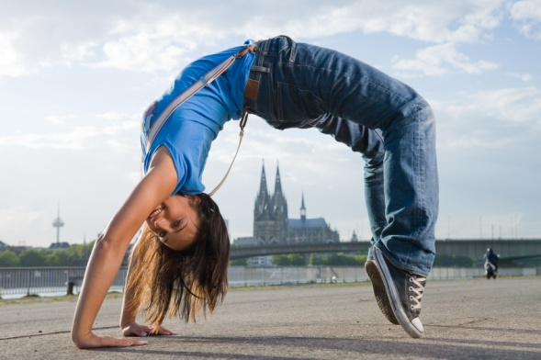

**GYMNASTICS Program**

Gymnastics program includes:

1) Movement patterns including foundational skills:

* Springs (hops, skips, gallops, leaps, jumps)
* Swings
* Landings (from heights)
* Rotations (forward, backward, side)
* Twists (rolls, turns, spins, jumps)

2) Fitness Development

* Power and speed, Strength, Flexibility, Balance, Agility, Muscular endurance, Cardiovascular endurance

C:\Documents and Settings\Jon\Temporary Internet Files\Content.IE5\S5QBQP6V\MC900285850[1].wmf C:\Documents and Settings\Jon\Temporary Internet Files\Content.IE5\85Y3CDQJ\MC900320822[1].wmf

The Gymnastics program will include lesson plans that are individual movement/skill based, age appropriate and utilize the equipment available in your gym. The gymnastics lessons can be a single lesson or ongoing, progressive lessons over a set period of time, for example, 2 classes per week for 4 weeks.

I will plan, organize and facilitate safe, fun and active lessons for students based on their age and abilities.

**Typical Gymnastics lesson will include;**

Fun, dynamic warm-up activity, safe stretching, gymnastic skill development and lesson, activity circuit and an effective cool-down activity.

**DANCE Program**

C:\Documents and Settings\Jon\Temporary Internet Files\Content.IE5\9IZLPUWU\MC900078766[1].wmf

Dance program includes:

1. Elements of movement and dance technique (spatial and kinesthetic awareness)
2. Musicality, rhythm, tempo, beat
3. Creation and Composition (expressing individuality, ideas, feelings through creation of unique and group dance pieces)
4. Presentation and Performance (learn choreography and perform as a group)
5. Learn history of dance and cultural dance forms

The Dance program will include lesson plans and music that are age-appropriate, fun, and accessible to all students.

Dance styles can include: HipHop/Breakdance, Jazz, African, Swing Dance/LindyHop/Rockabilly, Modern/Contemporary, and Line Dance.

Depending on your Physical Education program needs, lessons can be 1 class or a series of classes. To create and perform choreography, I recommend more than 2 lessons per class.

**Typical Dance class will include**:

warm-up and stretches, dance technique, cross-floor dance practice, musicality work, individual and small group creative work, group choreography and cool-down activity.

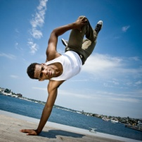

**YOGA Program**

[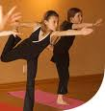](http://www.livlotus.com/Teens/Resources/phototeen.png)

Yoga for youth is a dynamic, fun and energizing movement based program that stretches the body and mind to increase strength, flexibility, balance, coordination, and joint stability through a variety of poses. As well, Yoga can help students decrease stress through relaxation and breathwork to stay alert, yet relaxed while studying and working in class. Classes are non-judgemental and non-competitive which helps students develop at their own pace. Through heightened levels of awareness, self-respect and empowerment, Yoga classes can help students make healthy choices, increase self-esteem, create a positive body image and allow for more respect for self, others and the environment.

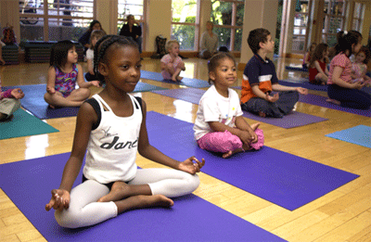

**Typical Yoga class will include:**

Introduction to Yoga and Yoga etiquette (respectful behavior), warm-up poses and deep breathing, dynamic sequence of poses leading to a peak pose and then cool down poses and relaxation.

**All lessons = $50/lesson**